

**NALUWERERERE – BUGIRI MUNICIPALITY**

END OF TERM ONE,2023 EXAMS

**PRIMARY FOUR SCIENCE**

**NAME:_____________________________________________________________________**

**SECTION A**

1. Which type of soil is used for making pots?

__________________________________________________________________

1. What is the importance of carbohydrates in our diet?

__________________________________________________________________

1. Give a reason why sound travels fastest through solids.

__________________________________________________________________

__________________________________________________________________

1. State any one characteristics of arthropods.

__________________________________________________________________

1. Why is displacement method used to find the volume of objects like a stone?

__________________________________________________________________

1. Which practice in goat management prevents inbreeding?

__________________________________________________________________

1. How is an eagle adapted to its mode of feeding?

__________________________________________________________________

__________________________________________________________________

1. Write any one advantage of mulching soil to a farmer.

__________________________________________________________________

1. Why is s duck billed platypus called a monotreme?

__________________________________________________________________

**The diagram below shows a root system of a plant. Use it to answer questions 10 and 11.**

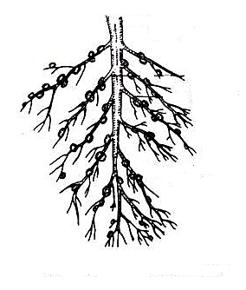

X

1. Name the type of root system shown in the above diagram.

__________________________________________________________________

1. State the function of part X in the above diagram.

__________________________________________________________________

1. Give any one component of a balanced diet.

__________________________________________________________________

1. Which type of thermometer is used to measure the highest and lowest temperature of the day?

__________________________________________________________________

1. How do people benefit from eating fish?

__________________________________________________________________

__________________________________________________________________

1. Give any one way in which plants protect themselves from their enemies.

__________________________________________________________________

1. Name any one animal product used as food.

__________________________________________________________________

1. How does heat from the fire reach meat being roasted?

__________________________________________________________________

1. In the space below, draw a foot of a swimming bird.
2. How is pulmonary vein different from other veins in the body?

__________________________________________________________________

__________________________________________________________________

1. Give any one way echoes can be reduced in a cinema hall.

__________________________________________________________________

1. How useful is a pit latrine at home?

__________________________________________________________________

__________________________________________________________________

1. What name is given to the physical process by which water turns into ice?

__________________________________________________________________

1. State any one game that can be played using air.

__________________________________________________________________

**The diagram below is of a fish. Use it to answer questions 24 and 25.**

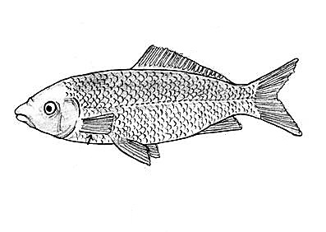

Q

Y

X

**X**

1. How useful is part marked Y to a fish?

__________________________________________________________________

1. Which part of an insect serves the same function like part labeled Q above?

__________________________________________________________________

1. Name the natural hazard whose effect can cause displacement of people living around swamps.

__________________________________________________________________

1. Give any one effect of alcoholism to an individual.

__________________________________________________________________

1. Write any one factor that affects the pitch of sound.

__________________________________________________________________

1. State one way of controlling soil erosion on hilly areas.

__________________________________________________________________

1. How can parents control poisoning of children in their homes?

__________________________________________________________________

__________________________________________________________________

1. Give a reason why a flute is grouped under wind musical instruments.

__________________________________________________________________

__________________________________________________________________

1. State any one way a farmer can prevent his garden tools from rusting.

__________________________________________________________________

1. Why is it important to cover the mouth with handkerchief while coughing?

__________________________________________________________________

__________________________________________________________________

1. Name the natural fibre got from a boar goat.

__________________________________________________________________

1. Write the type of family which is made up of father, mother and uncle.

__________________________________________________________________

1. Give any one body sense.

__________________________________________________________________

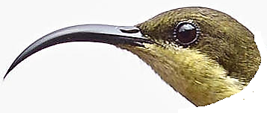**The diagram below shows a beak of a bird. Use it to answer questions 37 and 38.**

1. Give any one example of a bird with such a beak.

__________________________________________________________________

1. How is the above beak adapted to its function?

__________________________________________________________________

__________________________________________________________________

1. Why do some objects float on water?

__________________________________________________________________

__________________________________________________________________

1. In which way is poultry farming important to a crop farmer?

__________________________________________________________________

**SECTION B**

1. (a) State any one characteristic of a physical change in the environment.

__________________________________________________________________

(b) Give any one example of a chemical change.

__________________________________________________________________

(c) How is a biological change important to a living thing?

__________________________________________________________________

__________________________________________________________________

(d) Why do some snakes shed off their skin?

__________________________________________________________________

__________________________________________________________________

1. **Match the vertebrates in list X to the group they belong to in list Y.**

**List X List Y**

Chameleon Amphibians

Tilapia Reptiles

King fisher Fish

Salamander Birds

1. Chameleon _____________________________________________________
2. Tilapia _____________________________________________________
3. King fisher _____________________________________________________
4. Salamander _____________________________________________________
5. **The diagram below is of a female animal. Use it to answer the questions that follow.**

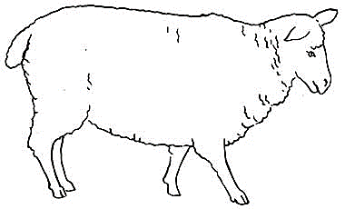

D

1. Which animal is shown in the diagram above?

__________________________________________________________________

1. Name the part of the animal marked D.

__________________________________________________________________

1. Give the advantage of cutting short part marked D to this animal.

__________________________________________________________________

1. State any one product got from the animal drawn.

__________________________________________________________________

1. (a) Name the two types of clouds found in the sky.
2. _____________________________________________________________
3. _____________________________________________________________

(b) Which type of cloud gives a farmer rain?

__________________________________________________________________

(c) Why should crop farmers study about weather changes?

__________________________________________________________________

__________________________________________________________________

1. (a) Apart from distillation, name one other method of making alcohol.

__________________________________________________________________

(b) Name the fungus used in the process of making alcohol.

__________________________________________________________________

(c) Give two uses of alcohol in the hospital.

1. _____________________________________________________________
2. _____________________________________________________________
3. (a) Who are vulnerable people?

____________________________________________________________________________________________________________________________________

(b) Apart from pregnant mothers, mention any two groups of vulnerable people.

1. _____________________________________________________________
2. _____________________________________________________________

(c) Suggest any one activity family members can do to help vulnerable people.

__________________________________________________________________

1. **The diagram below shows eggs of two amphibians. Use it to answer questions that follow.**

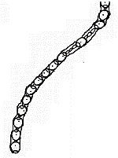

A

B

1. Name the amphibian which lays eggs marked:

A ___________________________ B ___________________________

1. How are the above eggs protected from predators?

__________________________________________________________________

__________________________________________________________________

1. What type of fertilization is common in all amphibians?

__________________________________________________________________

1. (a) State any two methods of heat transfer.
2. _____________________________________________________________
3. _____________________________________________________________

(b) Give any one use of heat to people.

__________________________________________________________________

(c) Why are gaps left in between rails during the construction of the railway line?

__________________________________________________________________

__________________________________________________________________

1. (a) what are root crops?

__________________________________________________________________

__________________________________________________________________

(b) Give any two examples of root crops apart from cassava.

1. _____________________________________________________________
2. _____________________________________________________________

(c) How is cassava propagated?

__________________________________________________________________

1. 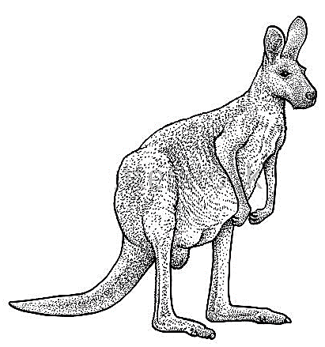**The diagram below is of a mammal. Use it to answer the questions that follow.**
2. Name the group of mammals to which the above mammal belongs.

__________________________________________________________________

1. Apart from the above mammal, give any two other examples of mammals in the same group.
2. _____________________________________________________________
3. _____________________________________________________________
4. State one way in which the above mammal is adapted to its mode of life.

__________________________________________________________________

1. **The table below shows deficiency diseases, causes and prevention. Study it carefully and complete it correctly.**

|  |  |  |
| --- | --- | --- |
| **Deficiency disease** | **Cause** | **Prevention** |
| Goitre | _____________________ | Eat food rich in iodine |
| _____________________ | Lack of proteins | Eat food rich in proteins |
| Scurvy | Lack of vitamin C | _____________________ |
| _____________________ | Lack of calcium | Sun bathing in the morning |

1. (a) Name any two types of families.
2. _____________________________________________________________
3. _____________________________________________________________

(b) Give any one role of each of the following at home:

1. Father _____________________________________________________
2. Child _____________________________________________________
3. (a) Apart from white blood cells, name any two other components of blood.
4. _____________________________________________________________
5. _____________________________________________________________

(b) Which blood cell is destroyed by malaria parasite?

__________________________________________________________________

(c) Name the component of blood which fights against disease causing germs in the

body. _________________________________________________________

1. (a) Write two ways in which soil is formed.
2. _____________________________________________________________
3. _____________________________________________________________

(b) Give any one activity that can lead to soil exhaustion.

__________________________________________________________________

(c) How can a farmer control soil exhaustion in his garden?

__________________________________________________________________

1. (a) What is digestion?

__________________________________________________________________

__________________________________________________________________

(b) How useful is the ileum during the digestion process?

__________________________________________________________________

__________________________________________________________________

(c) Name any two food substances which is absorbed into the blood stream from the

stomach.

1. _____________________________________________________________
2. _____________________________________________________________